**USING BM25 AS SIMILARITY MEASURE IN TEXTRANK   
FOR TEXT SUMMARIZATION**

Thach Le – Minh Bach – Quang Nguyen

MS in Data Science

John Von Neumann Institute

Hackathon II - 2018

**Introduction**

Text summarization is a problem that has been studied for many years and various solutions and systems have been proposed and implemented. The task can be described as building a machine that is capable of making a summary when given a text. The key idea is to find a “smaller” set of data that contains the information of the entire data set.

There are two main approaches to this problem: Extraction and Abstraction. Extraction methods build the summary by selecting sentences having rich information in the given text. Meanwhile, abstractive methods aim at creating a summary using key ideas from the text by building an internal semantic representation and then use natural language generation techniques. Beside these methods, machine learning techniques in information retrieval and text mining have also been used to develop systems that aid users with the task of summarization. Examples for such systems include MAHS = Machine Aided Human Summarization, which highlights candidates to be included in the summary, and systems that depend on post-processing by a human (HAMS = Human Aided Machine Summarization).

**Background**

Extractive text summarization includes ranking words and sentences and use them to generate a summary. Therefore, these summaries include the most important sentences in the input in order. Some algorithms are supervised learning, which requires a corpus to identify descriptive words in a document to be summarized. To identify those words, statistical approach such as likelihood or TF-IDF. An unsupervised approach for text summarization is more robust because it doesn’t require corpus.

A graph-based ranking algorithm like Google’s PageRank is called TextRank. The TextRank model decides the importance of a vertex within a graph. The importance of a vertex is evaluated by the number of votes that are casted on that vertex, and for each vertex, the weight of its vote is influenced by its importance. Hence, with the same number of votes, the vertex that has more votes from important vertices will be considered more important.

Traditionally, directed graph is applied to TextRank model. In case of loosely connected graphs, undirected graph can be considered. Let $G=(V,E)$ be a directed graph with the set of vertices $V$ and set of edges $E$:

* $E$ will be a subset of $V×V$
* For a vertice $V_{i}$, predecessors are all the vertices $In(V_{i})$ that point to $V_{i}$
* $V_{i}$ will point to $Out(V_{i})$ call successors

Unlike web surfing context where a page is hardly include multiple or partial links to another page, graph-based ranking in the context of natural language texts, may exist multiple or partial links between the vertices. Therefore, it is useful to indicate the strength of the connection between two vertices $V_{i}$ and $V_{j}$ as weight $w_{ij}$.

**Proposed method**

We propose an extractive method using TextRank integrated with BM25 as a similarity measure between two sentences. We prefer this extractive approach to an abstractive one due to following reasons:

_The idea of abstractive method sounds appealing, however, it requires deep-learning algorithms and natural language processing, making it difficult to develop the model within the one-week time constraint.

_TextRank is a well-known and accurate extractive text summarization method whose foundation is the PageRank algorithm. The PageRank algorithm was developed by the Google Team and implemented in the Google Search.

_The performance of the algorithm depends strongly on how similarity measure is defined, which could be an area of improvement.

_The algorithm is an unsupervised learning method which doesn’t a training process.

**Description of the proposed method**

TextRank is a graph-based model. A given text is considered as a graph having vertices which are connected by edges. Each sentence in a text is a vertex. We compute the score of each vertex and then rank them to select high-score sentences forming the summary.

The score is computed based on these principles:

_The importance score of a vertex is measured by the number of vertices to which it links and the importance of those vertices.

_Links between two sentences are defined by similarity measures. This measure will then be integrated into computing the importance score as weights.

The following formula is used for computing the score of a vertex

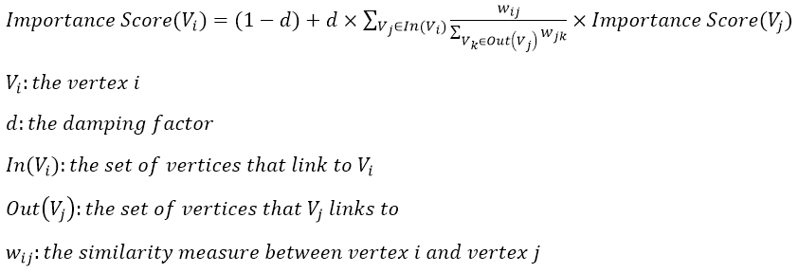

The damping factor is the probability of jumping from one vertex to another random vertex in the graph. $d$ could be set between 0 and 1. In our case, we choose $d=0.85$.

The original TextRank algorithm use this similarity measure to compute the weights

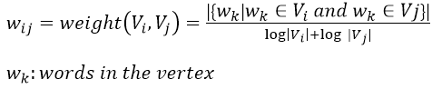

Starting from arbitrary values assigned to each vertex in the graph, the computation iterates until convergence below a given threshold is achieved. After running the algorithm, an importance score is associated with each vertex in the graph. The final values obtained after TextRank runs to completion are not affected by the choice of the initial value.

We also found a similarity measures that have shown to gain significant improvements. BM25 is known to be a ranking function as state of the art of information retrieval techniques. It is a variation of a TF-IDF model using probabilistic model

Given two sentences R and S, BM25 is defined as:

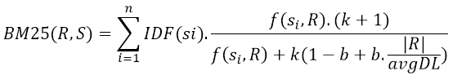

where k and b are parameters and avgDL is the average length of the sentences in our text. For our implementation, we choose k=1.2 and b=0.75.

$IDF\left(s_{i}\right)$ is the inverse document frequency. This term will be negative when $s_{i}$ appears more than half of the sentences in the text, which could cause some problems later on, therefore we made some adjustment to the formula:

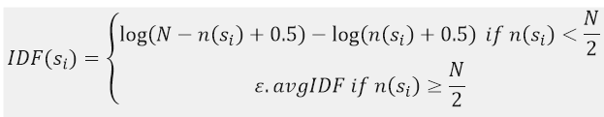

$ε$ is between 0.3 and 0.5 and $avgIDF$ is the average IDF of all of the words in the text.

**Experiment**

We used data from the 2003 Document Understanding Conference (DUC). The dataset contain one input text and four reference summaries.

We tried to compare results from two summary models:

_TextRank with original similarity measure

_TextRank with BM25 as similarity measure.

First, we use the models and the input data to produce the summaries. To evaluate the results, we use three evaluation tools: ROUGE-1, ROUGE-2 and ROUGE-L. These evaluation tools will compute the scores of our models based on the summary produced by the models and the reference summary.

The following table shows the results of evaluation.

**Results**

|  |  |  |  |  |
| --- | --- | --- | --- | --- |
| **Method** | **Reference summary** | **ROUGE-1** | **ROUGE-2** | **ROUGE-L** |
| **Textrank** | ref0 | 0.3533 | 0.0638 | 0.1490 |
| ref1 | 0.3703 | 0.0645 | 0.1533 |
| ref2 | 0.3640 | 0.0560 | 0.1374 |
| ref3 | 0.3385 | 0.0570 | 0.1341 |
| **average** | **0.3565** | **0.0603** | **0.1435** |
| **BM25** | ref0 | 0.3755 | 0.0674 | 0.1560 |
| ref1 | 0.3890 | 0.0687 | 0.1591 |
| ref2 | 0.3777 | 0.0612 | 0.1431 |
| ref3 | 0.3558 | 0.0616 | 0.1404 |
| **average** | **0.3745** | **0.064725** | **0.14965** |

Using BM25 as the similarity measure has shown to improve the scores in each time of evaluation. On average, BM25 helps increase the scores by 5.55%.

**Guidance for implementation**

For further details on how to implement the model and reproduce the results, please refer to the file README.md